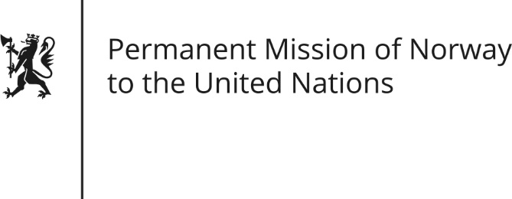

STATEMENT by First Secretary Paul Ø. Bjørdal

30th Session of the Universal Periodic Review

15 May 2018

Check against delivery

President,
Norway welcomes Cuba’s continued efforts to promote economic, social and cultural rights and its efforts to promote the social inclusion and rights of the LGBTI community.
Norway recommends that Cuba quickly proceed towards ratification of both the ICCPR and the ICESCR without reservations.
Norway remains concerned about the lack of freedom of expression, assembly and association in Cuba. Furthermore, Norway recommends that Cuba develop and implement specific laws, policies and mechanisms that recognize and protect the work of civil society, human rights defenders and journalists.
Norway has noted that Cuba has received several Special Procedures, and we recommend that Cuba issue a standing invitation to all Special Procedures, including those working in the field of civil and political rights.
Thank you

