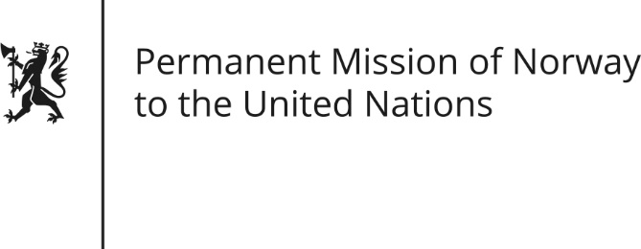

STATEMENT by First Secretary Paul Ø. Bjørdal

30th Session of the Universal Periodic Review

15 May 2018

Check against delivery

President,
Norway welcomes the delegation of the Republic of Azerbaijan.
We remain deeply concerned about human rights developments in Azerbaijan. Since the last hearing, we have noted the additional restrictions placed on civil society with particular concern.
Norway recommends that Azerbaijan:
- Immediately and unconditionally release all prisoners arrested on political grounds, including Mr Ilgar Mammadov, and adopt safeguards against arbitrary or politically motivated detention.
- Review its legislation regarding NGOs in order to ensure a safe and enabling environment for them to operate and have free access to funding.
- Let the internet remain an arena for free speech, particularly by unblocking the oppositional websites closed in the spring of 2017, and stopping the persecution of people voicing critical opinions online.
Thank you.

