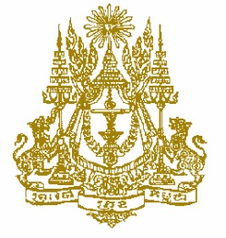

STATEMENT BY CAMBODIA
Review of Bangladesh
30^{t} Session of the UPR Working Group
14 May 2018 at 9.00 to 12.30 am

Mr. President,

- Cambodia warmly welcomes the delegation of Bangladesh, led by Minister of Foreign Affairs, H.E Mr. Shahriar Alam and congratulates him and his team for insightful and comprehensive presentation on the national report at the 30th Session of the UPR.

- My delegation is pleased to note that the Government of Bangladesh implementing the majority of recommendations accepted during the 2nd UPR Cycle. Bangladesh has passed and amended a number of human rights related legislations to further strengthen the promotion and protection of human rights for the peoples.

- We also appreciate the further achievements that Bangladesh has made in the areas of economic and social development programs such as poverty reduction, food security, healthcare and housing, education, religious protection, employment, protection for women-children, migrant issues, and human trafficking.

- We commend Bangladesh for its strong commitment to transform the country into a middle-income country by 2021 and a developed country by 2041.

- Cambodia encourages the Government of Bangladesh to ensure adequate resources for strengthening national institutions that promote human rights, democracy, good governance and the rule of law.

I thank you, Mr. President.

