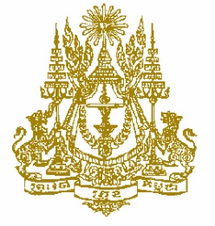

STATEMENT BY CAMBODIA
Review of the Cuba
30th Session of the UPR Working Group
16 May 2018 at 14.30 am to 18 pm

Mr. President,

- Cambodia warmly welcomes the Cuban delegation to the 30th Session of the UPR Working Group and appreciate the very comprehensive national report presented.

- My delegation notes since the 1st and 2nd cycle of the UPR review process, the majority of UPR recommendations were accepted and implemented by Cuba. We applauded Cuban Government’s commitment to international human rights law. It has ratified 44 of all 61 international human rights treaties (or 72.13 per cent), placing it among the States members of the United Nations with the highest number of ratifications of such instruments.

- Cambodia also highly appreciates Cuba for protecting the lives of persons deprived of their liberty which is a high priority of the Cuban Government. All prisons have health facilities, medical and nursing personnel and sufficient resources and materials to guarantee the right to free medical care, and increase the knowledge of the population, from an early age, about the political system in the country, the ways to participate in the conduct of public affairs and the mechanism of accountability. To continue to implement appropriate measures to ensure equality of all its citizens.

- We commend Cuba for progress made in the process of updating its model of economic and social development for sustainable development and successfully implementing the national economic and social development plan up to 2030.

I thank you, Mr. President.

