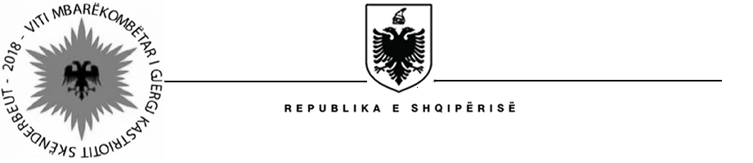

MISIONI I PËRHERSHËM I  REPUBLIKËS SË SHQIPËRISË  GJENEVË | PERMANENT MISSION OF  THE REPUBLIC OF ALBANIA  GENEVA

Universal Periodic Review

29th
Session

(15 – 26 January 2018)

Albania Intervention on the Third Cycle of the UPR of Burundi

Geneva, 18th of January 2018

-Check against delivery-

Thank you Mr. President,

Albania thanks the delegation of Burundi for presenting their national report before the Council under the third UPR cycle.

We are concerned little commitment by Burundi towards implementation of recommendations received during the second cycle of UPR. Burundi still faces challenges connected with persistent violence, especially since 2015, when lives were lost in the country and perpetrators remains unidentified.

We are disappointed that human rights defenders have been subjected to violence, arbitrary detention, attempted killings and enforced disappearances.

Albania would like to make the following recommendations:
- To re-establish the cooperation and collaboration with OHCHR and Commission of Inquiry by allowing their members unhindered access to the country and relevant sites and people.
- To sign the Second Optional Protocol to the International Covenant on Civil and Political Rights, aiming at the abolition of the death penalty;
- Immediately cease torture and other ill-treatment of detainees and allow them to have a fair trial;
- Accelerate the domestic law reform and harmonize all laws in line with CEDAW Convention and ensure their effective implementation.
In conclusion, Albania wishes to the delegation of Burundi a successful review.

Thank you,

