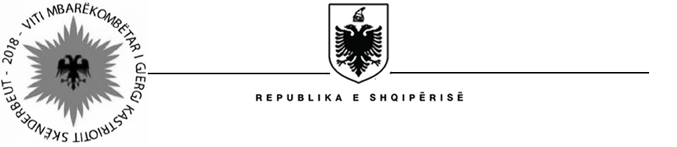

MISIONI I PËRHERSHËM I  REPUBLIKËS SË SHQIPËRISË  GJENEVË | PERMANENT MISSION OF  THE REPUBLIC OF ALBANIA  GENEVA

Universal Periodic Review

29th
Session

(15 – 26 January 2018)

Albania Intervention on the Third Cycle of the UPR of Romania

Geneva, 16th of January 2018

-Check against delivery-

Thank you Mr. Vice President,

Albania welcomes the distinguished delegation of Romania, headed by the State Secretary Mr. Micula, for their comprehensive national report and its presentation today.

We commend national level strategies and developments concerning strengthening the integrity and transparency of Judiciary System, Education and Anticorruption measures adopted by Romania since their Second Cycle of UPR.

Albania welcomes Romania regarding the acceptance of international norms, cooperation with treaty bodies and developing institutional framework to comply with Paris Principles.

Albania would like to make the following recommendations:

- Consider ratifying the Optional Protocol to the Convention on the Rights of Persons with Disabilities and the Optional Protocol to the Convention on the Rights of the Child on a communications procedure;
- Take appropriate measures to give full access to education, health care, employment and social inclusion to Roma children.
- Implement the Deinstitutionalization Plan for Children in Residential Care and Ensuring their Transition to Community-based Care (2016) and put in place a strong monitoring system;

In conclusion, Albania would like to wish to the delegation of Romania a very successful review during this cycle.

Thank you,

