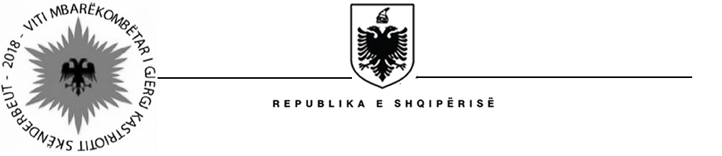

MISIONI I PËRHERSHËM I  REPUBLIKËS SË SHQIPËRISË  GJENEVË | PERMANENT MISSION OF  THE REPUBLIC OF ALBANIA  GENEVA

Universal Periodic Review

29th
Session

(15 – 26 January 2018)

Albania Intervention on the Third Cycle of the UPR of France

Geneva, 15th of January 2018

-Check against delivery-

Mr. President,

Albania welcomes the distinguished delegation of France, headed by Ambassador of Human Rights, Mr. Francois Croquette, for their comprehensive national report and its presentation today.

We commend the progress made by France for the promotion and protection of human rights at the national level and the support provided at the international level.

We welcome Government’s priority and reform policy towards combating racial discrimination, xenophobia and anti-Semitism and commend the fifth inter- ministerial plan (2017-2019) on preventing and combating violence against women and promoting equality between women and men.

Albania note the work done by France on strengthening rights of immigrants and asylum seekers.

Albania make the following recommendation to France:
- Strengthen the implementation of gender equality policies at the municipal and regional levels.

In conclusion, Albania would like to wish to the delegation of France a very successful review during this cycle.

