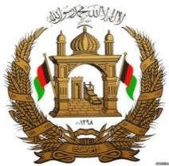

Permanent Mission of the I. R. of Afghanistan to UNOG

29th Session of the UPR working group

Review of Serbia

24 January 2018

Mr. President,

Afghanistan would like to extend a warm welcome to the distinguished delegation of Serbia to the 29th session of the UPR working group and congratulates for the comprehensive and well-elaborated presentation of the national report.

Mr. President,

Afghanistan believes that policies and actions aiming at gender equality is crucial in promotion and protection of human rights. My Government, therefore, commends the actions by Serbia toward gender equality and efforts aiming to improve the status of women that have been undertaken by the Coordination Body for Gender are noteworthy.

While commending several aspects of Serbia endeavours to improve human rights, my delegation wishes to propose the following recommendations to the distinguish delegation of Serbia:

1- To finalize the ratification of the International Convention on the Protection of the Rights of All Migrant Workers and Members of Their Families,

2- To take necessary steps to ensure the rights of minorities particularly that of the Roma minority group are respected

In conclusion, Afghanistan wishes all success to the distinguished delegation of Serbia.

Thank you - Mr. President.

