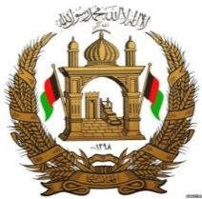

Permanent Mission of the I. R. of Afghanistan to UNOG

29th Session of the UPR working group

Review of United Arab Emirates

22 January 2018

Mr. President,

Afghanistan would like to extend a warm welcome to the distinguished delegation of the UAE to the 29th session of the UPR working group and congratulates for the comprehensive and well-elaborated presentation of the national report.

Mr. President,

Afghanistan commends the legislative steps that have been taken by the UAE in promoting and protecting human rights. The federal Decree-Law on combating discrimination and hatred as well as the amendments to the provisions of the Federal Anti-Human Trafficking Act are noteworthy.

Afghanistan wishes to recommend to the UAE to ratify the International Convention on the Rights of Migrant Workers and their Family members, the ILO Convention on Domestic Workers, and to consider the human rights of trafficked persons at the centre of any anti-trafficking policies and measures that the country adopts.

In conclusion, Afghanistan wishes all success to the distinguished delegation of the UAE.

Thank you - Mr. President.

