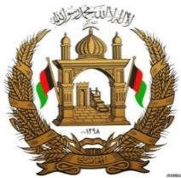

Permanent Mission of the I. R. of Afghanistan to UNOG

29th Session of the UPR working group

Review of Liechtenstein

24 January 2018

Madam. Vice President,

Afghanistan would like to extend a warm welcome to the distinguished delegation of Liechtenstein to the 29th session of the UPR working group and congratulates for the comprehensive and well-elaborated presentation of the national report.

Madam. Vice President,

Afghanistan values the endeavours have been made by Liechtenstein in order to implement the recommendations of the last UPR cycle. My delegation notes with appreciation the establishment of an independent National Human Rights Institution (NHRI) in accordance with the Paris Principles by Liechtenstein and urges the Government of Liechtenstein to enhance the mentioned institution.

While commending the policies and actions that have been made by Liechtenstein to improve human rights, my delegation wishes to propose the following recommendations to the distinguished delegation of Liechtenstein:

1- To ensure full implementation of the 1951 convention on the status of refugees,
2- To consider ratifying the International Convention on the Protection of the Rights of All Migrant Workers and Members of Their Families.

In conclusion, Afghanistan wishes all success to the distinguished delegation of Liechtenstein.

I Thank you, Madam, vice-president,

