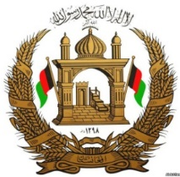

Permanent Mission of the I. R. of Afghanistan to UNOG

29th Session of the UPR working group

Review of Burundi

18 January 2018

Mr. President,

Afghanistan would like to extend a warm welcome to the distinguished delegation of Burundi to the 29th session of the UPR working group and congratulates for the comprehensive and well-elaborated presentation of the national report.

Mr. President,

Burundi has successfully established gender units within the government institutions, which have a positive impact on the protection and promotion of women’s rights and gender mainstreaming in the policy and implementation. Therefore, my Government commends the establishment of gender units in the various ministries of the Government of Burundi aiming to improve women’s rights. The implementation of the Act on the punishment of gender-based violence and the establishment of the special court chambers for juveniles and gender-based violence by Burundi are noteworthy.

Afghanistan wishes to propose the following recommendations to the distinguished delegation of Burundi:

- To take all necessary steps ensuring the independence of the National Human Rights Commission of Burundi.
- To ensure full cooperation with all internationally recognized human rights bodies and mechanisms.

Afghanistan wishes the distinguished delegation of Burundi a successful review.

Thank you - Mr. President.

