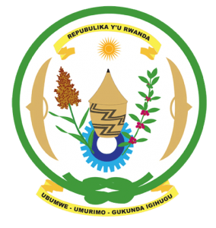
28th Session of the Universal Periodic Review Working Group
Review of Botswana
17th November 2017
Statement by Rwanda delivered by Mr. Moses Rugema

Thank you, Mr. Vice President,
- Rwanda warmly welcomes the delegation of Botswana and thanks them for the presentation of their national report and for the update just provided by the Honourable Minister.
- Rwanda welcomes the many positive steps taken by the Government Botswana to promote human rights and strengthen the institutional framework for the promotion and protection of human rights. In that regard, we welcome the positive steps taken by Botswana to establish an NHRI in accordance with the Paris Principles. We further commend Botswana’s positive contribution to the work of the Human Rights Council during her tenure as a member of this Council.
- While taking note of the positive steps taken by Botswana to confer the rights contained in various international human rights treaties, we encourage Botswana to consider ratifying the International Covenant on Economic Social and Cultural Rights (ICESCR) and the Convention on the Rights of Persons with Disabilities (CPRD) in order to better guarantee the rights contained therein.

Rwanda recommends that Botswana:
- Takes active steps to ensure that public consultations on the death penalty including on its abolition are held and include information on the outcome of those consultations in its next UPR report.
- Consider ratifying the Genocide Convention in view of the upcoming 70th anniversary of its ratification.

We wish Botswana every success in implementing the outcomes of this review. Thank you.

