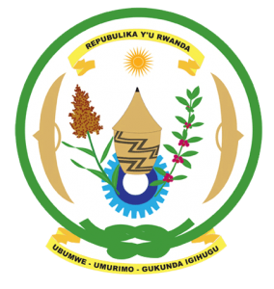
29th Session of the Universal Periodic Review Working Group
Review of France
15th January 2018

Statement by Rwanda delivered by H.E. Dr. Francois Xavier Ngarambe
- Rwanda welcomes the delegation of France and thanks them for the presentation of their national report and the update just provided.
- Rwanda takes note of France’s continued efforts to promote and protect human rights including through implementation of the recommendations of its second cycle UPR.
- Rwanda however remains concerned that France has taken minimal steps to ensure that those perpetrators of the 1994 Genocide against the Tutsi residing in France are held accountable.
Rwanda recommends that France:
- Take active steps to either prosecute or extradite suspected genocide perpetrators residing in its territories as required under international law;
- Take immediate steps to cooperate with the ICTR by prosecuting Wenceslas Munyeshyaka and Laurent Bucyibaruta or, alternatively, ensure their immediate return to the UN MICT;
- Take active steps to declassify and make public all documents that contain Government and military information relating to the pre, during and post genocide period;
- Take active steps to investigate allegations emanating from various sources since 1994 of its role in the Genocide against the Tutsi:

Thank you

