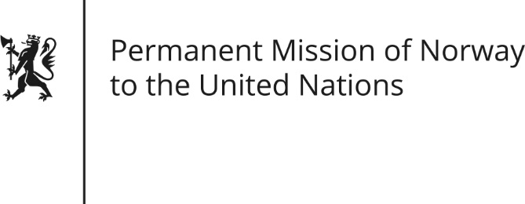

STATEMENT by First Secretary Paul Ø. Bjørdal

29th Session of the Universal Periodic Review

United Arab Emirates

22 January 2018

Check against delivery
Mr President,

President,
Norway welcomes the delegation of the United Arab Emirates to this UPR hearing.
Norway has taken due note of the new federal law on domestic workers to protect and regulate their contractual arrangements. We recommend that further measures be taken to ensure that the law is properly implemented to ensure domestic workers are protected from abuse.
We recommend that the UAE review the legal framework and amendments preventing freedom of expression.
Finally, Norway recommends that the UAE take steps to protect human rights defenders. We stress the importance of a fair and transparent legal process, and the release from custody of any individual detained for their peaceful exercise of freedom of expression and assembly.

Thank you.

