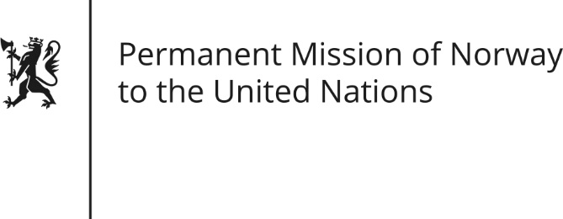

STATEMENT by Minister Counsellor Herborg F. Alvsaaker

29th Session of the Universal Periodic Review

Serbia

24 January 2018

Check against delivery

Mr. President,

We welcome the delegation of Serbia and for their comprehensive report.

Serbia deserves credit for progress made in many areas. More work, however, is needed to consolidate the rule of law and in particular in strengthening the judiciary. Norway recommends Serbia to strengthen the rule of law through constitutional amendments as well as other reforms that enhances the independence and efficiency of the judiciary.

The distortion of competition in the media market due to subsidies and weak competition rules is another case of concern, as political diversity in media is necessary for a well-functioning democracy. Norway recommends Serbia to implement reforms on media ownership and revenues, with the aim of guaranteeing transparency and a level playing field for media regardless of ownership and affiliations.

We commend efforts made to protect against hate crime, such as explicitly prohibiting hate speech. However, as pointed out in several Council of Europe reports, more measures are needed. Norway recommends that the legislation against hate speech is applied more efficiently, given reports of continued rise in hate speech in the Serbian public discourse.

Thank you.

