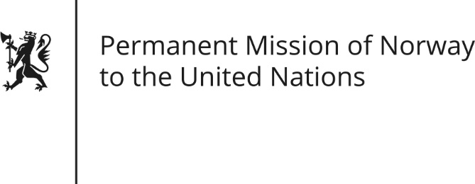

STATEMENT by Minister Counsellor Herborg F. Alvsaaker

29th Session of the Universal Periodic Review

Romania

16 January 2018

Check against delivery

Mr. President

Norway thanks the Romanian delegation for presenting its national report.

Norway recognizes Romania’s efforts (since 2007) to undertake judicial reform and fight corruption. We recommend Romania to continue judicial reforms and fight corruption in line with international standards.

Although important progress, Roma children and children with disabilities still face discrimination. Norway recommends Romania to provide funding and human resources in rural areas to reduce and eliminate disparities, with particular focus on access to education, access to birth registration and abolishment of classroom segregation.

Norway further recommends Romania to intensify efforts to prevent trafficking in children, in particular by training teachers and raising awareness of children through education, and paying special attention to poor communities and migrant children.

Finally, Norway recommends that Romania enhance the efforts to protect persons with disabilities, by renewing co-operation with expert NGOs and by conducting thorough investigations into allegations of abuse.

Thank you.

