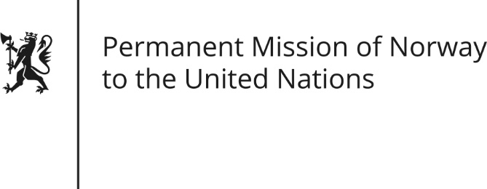

STATEMENT by Ambassador Hans Brattskar

29th Session of the Universal Periodic Review

Mali

16 January 2018

Check against delivery
Mr President,

The development of the human rights situation in Mali is not only dependent on the actions of the authorities, but of all signatory parties to the peace agreement. Norway recommends that Malian authorities accelerate efforts to reestablish state authority and rule of law in all areas of the country, including the northern and central regions.
Norway recommends that allegations of human rights violations during the continued crisis in Mali committed by all parties, including Malian defense and security forces, must be investigated. Human rights violations by all signatories to the peace accord must be prosecuted and perpetrators must be brought to justice.
Norway is particularly concerned by continued impunity for violence against women, including FGM, and the disastrous effects of the crisis on the right to education. Norway recommends Mali to do its utmost to safeguard the fundamental rights of all citizens, regardless of gender and ethnicity, in line with relevant international human rights instruments, including the right to education.
Finally, Norway recommends that Mali adopts criminal laws explicitly prohibiting Female Genital Mutilation.

Thank you.

