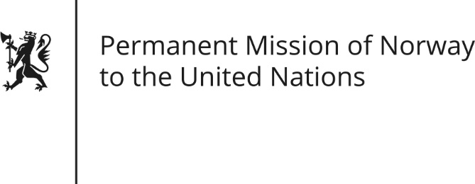

STATEMENT by Ambassador Hans Brattskar

29th Session of the Universal Periodic Review

Israel

23 January 2018

Check against delivery
President,

Norway welcomes the presentation of Israel’s national report. In particular, we commend Israel’s progressive stance on LGBT rights, and we note progress made for certain social rights.

We are deeply concerned about the unresolved Israeli-Palestinian conflict and its consequences for the full realization of the human rights of the Palestinian population.

Norway recommends that the use of administrative detention against Palestinians, especially minors, is minimized and in compliance with international human rights standards.
Norway recommends that Israel intensify efforts to advance the rights of its Arab minority populations.

Norway places great emphasis on the positive role of civil society and human rights defenders in building sustainable, open and democratic societies. Norway recommends that Israel ensure that Israeli and Palestinian civil society actors, including human rights defenders, can exercise their freedom of speech and carry out their work unhindered.

Thank you.

