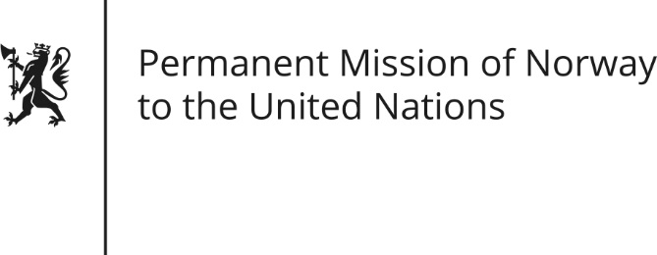

STATEMENT by Minister Counsellor Herborg F. Alvsaaker

29th Session of the Universal Periodic Review

France

15 January 2018

Check against delivery
Mr President,

Norway welcomes the French delegation and its presentation of the report.

Norway recommends that France address the issues identified by the European Committee for the prevention of Torture (CPT) report from 2017, where the problems linked to overcrowded prisons appear to require urgent measures.

Recognizing the progress made, Norway recommends that France introduces further measures to address the issue of hate speech in order to effectively combat discrimination and intolerance, and that an independent review mechanism of relevant National Action plans is put in place.

Norway recommends close monitoring and evaluation of the implementation of the legislative amendments to combat terrorism, in order to ensure that individual liberties and human rights are fully protected.

Thank you.

