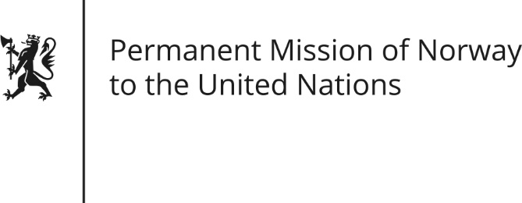

STATEMENT by Counsellor Robert Hovde

29th Session of the Universal Periodic Review

Burundi

18 January 2018

Check against delivery
Mr President,

Norway continues to be gravely concerned over the rampant human rights violations in Burundi.
We recommend that extrajudicial killings, forced disappearances, torture and sexual violence be promptly investigated and that the perpetrators be brought to justice.
Norway recommends that freedom of expression and assembly be fully respected, independent media reopened, and persecution of human rights defenders, civil society actors and opposition politicians put to an end.
We recommend that Burundi gives full and unhindered access in the country the Commission of Inquiry established by the Human Rights Council and that the Government fully cooperate with the Commission.
We recommend that prompt action be taken to prevent Imbonerakure from continuing the reported abuses and illegal activities.
Finally, we recommend that the government engage constructively with the opposition to find a solution to the crisis in Burundi that is conducive to free, fair and peaceful elections in 2020.
Thank you.

