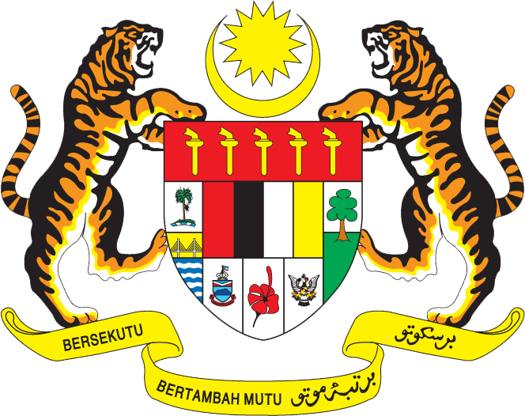

Statement by Mr. Syed Edwan Anwar, Minister Counselor
Permanent Mission of Malaysia to the United Nations Office at Geneva
and other International Organisations

Review of Tonga

29th Session of the UPR Working Group of the Human Rights Council
15 – 27 January 2018

Mr. President.

Malaysia welcomes the delegation of Tonga and we thank them for the presentation of their national report.

- We are pleased that Tonga accepted both of Malaysia’s recommendations during the second cycle of the UPR. Malaysia welcomes the commitment of Tonga to facilitate access to education to its citizens, including through the adoption of the Education Act 2013, which makes education compulsory for those between the age of 4 and 18. We believe such legislation will assist Tonga in achieving the goal of universal primary education.

- Malaysia also notes efforts undertaken by the Government of Tonga to promote gender equality and build greater gender awareness, including through the Tonga Strategic Development Framework 2015-2025. Considering the important role women have played in Tongan culture and their growing role in both government and the private sector, Malaysia is confident that Tonga will succeed in achieving greater gender equality and awareness.

- Malaysia extends its best wishes to Tonga in its continued endeavors to promote and protect human rights.

I thank you, Mr. President.

Geneva
15 January 2018

