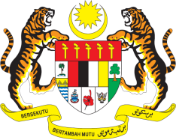

Statement by Ms. Kalpana Devi Rajantran
Permanent Mission of Malaysia to the United Nations Office at Geneva
and other International Organisations

Review of Romania

29th Session of the UPR Working Group of the Human Rights Council
15-26 January 2018
______________________________________________________________

Mr. President,

The Malaysian delegation welcomes the delegation of Romania. We thank them for the presentation of their national report.

- Romania’s effort in putting in place adequate legislative and institutional framework for promoting and protecting human rights is indeed encouraging. We note that several institutions have also been strengthened to monitor and ensure respect for human rights, including the rights of women and children.

- Malaysia is also encouraged to note Romania’s strong emphasis on making education at all-levels more accessible to a larger section of the population. This includes the setting up of Centers for Inclusive Education, as well as increased access to education for children with special needs and the adoption of a national strategy to prevent high number of school dropouts. Malaysia believes these efforts will significantly contribute to minimizing barriers to learning, and to ensuring that all segments of the society can obtain education in inclusive environment.

I thank you, Mr. President.

Geneva
16 January 2018

