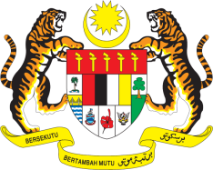

Statement by Ms. Kalpana Devi Rajantran
Permanent Mission of Malaysia to the United Nations Office at Geneva
and other International Organisations

Review of Montenegro

29th Session of the UPR Working Group of the Human Rights Council
15-26 January 2018
______________________________________________________________

Mr. President,

Malaysia welcomes the delegation of Montenegro. We thank them for presentation of their national report.

2. Malaysia notes that the Government of Montenegro has developed various national strategies to advance human rights in the areas of gender equality, education, rights of women, children and older persons, employment, social welfare and female entrepreneurship.

3. We hope the adoption of Law on Protection from Domestic Violence and National Strategy for Domestic Violence Protection 2016-2020 would contribute to addressing the incidences of domestic violence against women. A study conducted by UNDP in 2017 revealed that 42% of women experienced some form of violence and Montenegro is facing challenges in addressing this issue due to weak implementation, inadequate protection mechanism and lack of access for victims to seek justice.
4. In the spirit of constructive engagement and cooperation, Malaysia would like to propose the following recommendations consideration of Montenegro:

4.1. Ensure adequate shelters are made available for victims of domestic violence; and
4.2. Ensure victims of domestic violence are provided with counselling, rehabilitation and trainings are provided on regular basis to sensitise all key personnel and authorities handling cases of domestic violence support services.

I thank you Mr. President.

Geneva
22 January

