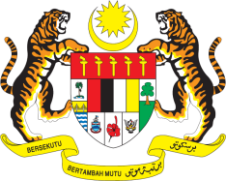

Statement by Ms. Kalpana Devi Rajantran
Permanent Mission of Malaysia to the United Nations Office at Geneva
and other International Organisations

Review of France

29th Session of the UPR Working Group of the Human Rights Council
15-26 January 2018
______________________________________________________________

Mr. President,

The Malaysian delegation welcomes the delegation of France to the 29th Session of the UPR Working Group, and thanks them for the presentation of France’s national report.

- Malaysia welcomes the ratification by France of the Third Optional Protocol to the CRC (Convention on the Rights of the Child). We also note the establishment of the High Councils for Gender Equality, for Family, Childhood and the Elderly, as well as of the National Child Protection Council, among others, as part of on-going effort to promote and protect human rights in the country.

- We further note that France has developed many programmes to prevent discrimination and racism in such areas as employment, education, sports and judiciary. This includes appointment of a contact judge in the Attorney-General’s Office. We hope these steps will enable France to address effectively the rise in racism, intolerance and xenophobic acts against minority groups.

- Malaysia wishes to recommend that France continue to enhance efforts to prevent acts of racism, intolerance and xenophobic against minority groups, particularly towards women and girls among its Muslim population, including by ensuring justice to victims of such acts.
I thank you, Mr. President.

Geneva
15 January 2018

