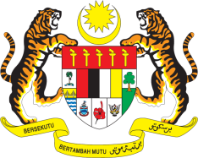

Statement by Mr. Syed Edwan Anwar
Permanent Mission of Malaysia to the United Nations Office at Geneva
and other International Organisations

Review of Burundi

29th Session of the UPR Working Group of the Human Rights Council
15-26 January 2018
______________________________________________________________

Mr. President,

Malaysia welcomes the delegation of Burundi and we thank them for presentation of their national report.

2. Malaysia commends the Government of Burundi for its commitment to improve the socio-economic development in the country demonstrated by government policies that focuses on people-centred development, poverty eradication, social justice and good governance such as the Vision Burundi 2025, Strategic Framework for Growth and to Combat Poverty, National Development Plan, Citizenship Education and Patriotic Training Programme and the Implementation of the Action Plan of the National Human Rights Policy 2012-2017.

3. We welcome efforts undertaken in promoting gender equality and addressing Gender Based Violence including through the implementation of the National Gender Policy Action Plan and the establishment of institutional frameworks such as the integrated gender based violence centers at hospitals and gender units in various ministries. We hope to see efforts to end gender-based violence (GBV) and ensuring women’s security remains a priority for the Government of Burundi.

4. Malaysia encourages Burundi to continue its endeavors to promote and protect human rights particularly the rights of children, women, the disabled and disadvantaged groups in the country.

I thank you Mr. President.

Geneva
18 January 2018

