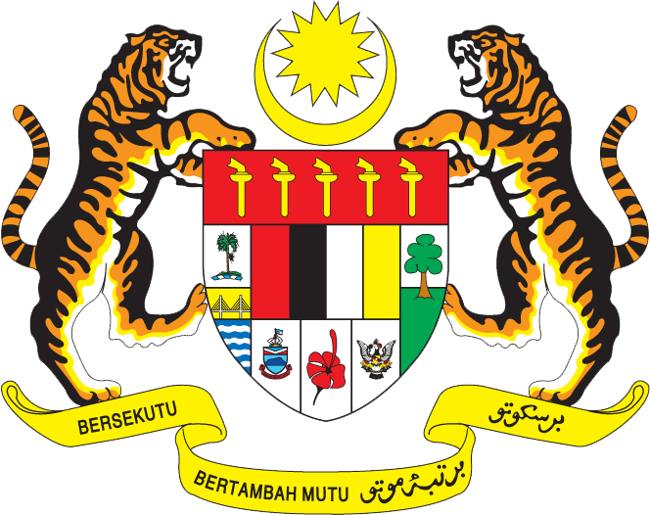

Statement by Mr. Syed Edwan Anwar, Minister Counselor
Permanent Mission of Malaysia to the United Nations Office at Geneva
and other International Organisations

Review of Botswana

29th Session of the UPR Working Group of the Human Rights Council
15 – 27 January 2018

Mr. President.

Malaysia welcomes the delegation of Botswana. We thank them for the presentation of their national report.

- Botswana continues to make progress in addressing poverty eradication whereby poverty in rural and urban areas has decreased by 6.5% and 3.5% respectively since 2002. Malaysia recommends that Botswana strengthen further efforts in this area, including by strengthening and addressing short-comings highlighted in the poverty eradication programmes (PEPs). The comprehensive approach adopted by Botswana to address poverty eradication by looking into areas such as livestock management, infrastructure, youth empowerment, women empowerment and addressing destitute persons is commendable.

- Malaysia is pleased that efforts to promote gender equality are reflected in Botswana’s National Vision 2036. We believe that greater gender equality will in the long-term facilitate economic development and prosperity in Botswana. Malaysia recommends that Botswana continue to put emphasis on gender equality and ensuring the rights of women and girls, including better access for them to education, aside from committing greater budgetary resources to the Women Economic Empowerment Programme. We note that other important avenues undertaken by the Government include engagement with traditional leaders to promote gender mainstreaming and providing scholarships to girls in the areas of science, mathematics, engineering and technology.

- Malaysia extends its best wishes to Botswana in its continued endeavors to promote and protect human rights.

I thank you, Mr. President.

Geneva
17 January 2018

