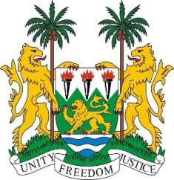
SIERRA LEONE
29th Session of the UPR

SERBIA

24 January 2018

Mr President,

Sierra Leone welcomes the distinguished delegation from Serbia and thanks them for their presentation.

My delegation commends Serbia for the establishment of a Coordination Body for Gender Equality in 2014 and an Action Plan and National Strategy for Gender Equality (2016-2020), as well as for implementing various measures to promote the active participation of women in high-level positions (62.4% are state employees, 53.23% women in leadership positions and 45% are state officials). In this connection, it is noteworthy that Serbia now has a female Prime Minister.

My delegation is also pleased to note that when a crime is committed out of hatred, the provisions for sentencing have been incorporated into the Criminal Code.

Sierra Leone would however encourage Serbia to adopt and implement a strategy to address the high level of domestic and intimate partner violence, and to put the necessary resources at the disposal of the Council for the Improvement of the Status of Roma and for the implementation of the Decade of Roma Inclusion to facilitate the social integration of the Roma people.

Serbia is encouraged to work with relevant stakeholders to facilitate the access of asylum seekers to a transparent and balanced asylum determination procedure.

Recommendations:

- Accede to the ICRMW.
- Develop and promote strategies aimed at promoting tolerance for persons belonging to ethnic, national, racial, religious and other minorities.

- Strengthen measures to combat and eliminate trafficking in persons, particularly migrants and refugees.

Sierra Leone wishes Serbia every success in completing their third review cycle.

Thank you, Mr President.

