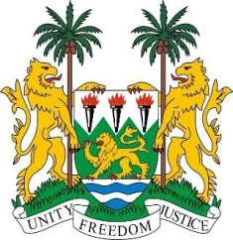
SIERRA LEONE

29th Session of the UPR

LIECHTENSTEIN

24 January 2018

Madam Vice-President,

Sierra Leone welcomes the distinguished delegation from Liechtenstein and thanks them for their presentation.

My delegation notes that Liechtenstein accepted the vast majority (74 out of 85) of the recommendations received during their last review and furthermore, applauds the government on the financial contributions it has made to the OHCHR since 2012.

Sierra Leone notes the recent ratification of several treaties and international agreements including the Optional Protocol to the CRC on a communications procedure in 2017, while in 2016, the Council of Europe Convention on Preventing and Combating Violence against Women and Domestic Violence (the Istanbul Convention) was signed.

It is commendable that in 2017, an independent national human rights institution which is in compliance with the Paris Principles was established, and that since 2003, Liechtenstein had issued a standing invitation to the thematic special procedures mechanisms of the Human Rights Council (HRC).

My delegation is however concerned that persons with disabilities still faced challenges in obtaining access to justice, education, employment and political participation.
Recommendations:

- Ratify the Convention on the Rights of Persons with Disabilities (CRPD) and accede to the ICPPED.
- Ensure that the Equal Opportunities Office is adequately resourced for the implementation of the National Action Plan against Racism.
- Increase official development assistance (ODA), with a view to meeting the international commitment of 0.7% of its gross national income (GNI).
- Develop strategies to encourage greater school attendance of migrant children at the higher levels of learning.
- Grant nationality to children born in Liechtenstein who would otherwise be stateless.

Sierra Leone wishes Liechtenstein every success in completing their third review cycle.

Thank you, Madam Vice-President.

