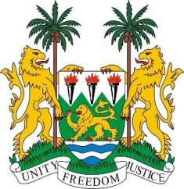
SIERRA LEONE
29th Session of the UPR

ISRAEL

23 January 2018

Mr President,

Sierra Leone welcomes the delegation from Israel to this session and thanks them for today’s presentation. My delegation notes that Israel contributed financially to the OHCHR in 2013 and thanks Israel for the assistance provided during the Ebola and mudslide disasters faced by Sierra Leone.

My delegation commends Israel for the measures taken to further promote and protect human rights - including the establishment of the Ministerial Committee on Social Equality in 2015 to tackle issues relating to gender equality in various spheres of society, which have yielded positive results. Also notable are the various recent amendments to national legislation to combat various forms of sexual offences and to raise the legal age of marriage to 18.

Sierra Leone would however encourage Israel to strengthen efforts to promote the equal treatment for all those living in its territories, including Arabs, Bedouins, Druze, Circassian, Palestinians and Israelis of Ethiopian Descent and cooperate more fully with the various human rights mechanisms.

Recommendations:

- Ratify and accede to the ICRMW and the ICPPED.
- Establish an independent national human rights institution which is in line with the Paris Principles.
- Ensure that reforms in the juvenile justice system which provide safeguards for children are implemented.
- Ensure that all children, whether born to migrant, asylum seekers or refugees living within its territory have access to birth registration.

Sierra Leone wishes Israel every success in completing its review cycle.

Thank you, Mr President.

