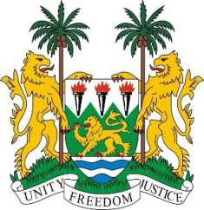
SIERRA LEONE
29th Session of the UPR

UNITED ARAB EMIRATES

22 January 2018

Mr President,

Sierra Leone welcomes the delegation from the UAE to this session and thanks them for their presentation. We note that since 2012, the UAE has contributed financially to the OHCHR, including to two Voluntary Funds.

Sierra Leone applauds the establishment of the National Strategy for Motherhood and Childhood (2017 -2021), as well as the National Vision 2021; the Strategic Plan for the Promotion or the Rights of Children with Disabilities; and the National Strategy for the Empowerment and Advancement of Emirati Women (2015-2021), as well as the various strategies to combat human trafficking.

Sierra Leone encourages the UAE to ratify the 1961 Convention on the Reduction of Statelessness and the ILO Domestic Workers Convention (No.189) of 2011.

Recommendations:

- Ratify and accede to the ICCPR, ICESCR, ICRMW and the ICPPED.
- Establish a National Human Rights Institution which is in accordance with the Paris Principles.
- Establish measures to facilitate access to justice, interpretation services and quality legal aid for migrant workers, stateless persons and domestic workers.
- Raise the age of criminal responsibility above 7 years of age.
- Modify the laws to enable Emirati women to pass nationality to their children.

Sierra Leone wishes the UAE success in completing their third review cycle.

Thank you, Mr President.

