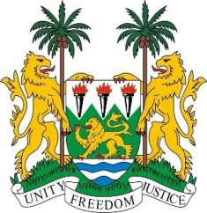
SIERRA LEONE
29th Session of the UPR

MONTENEGRO

22 January 2018

Madam Vice-President,

Sierra Leone welcomes the delegation from Montenegro to this session and thanks them for their presentation.

Montenegro, we note, has contributed financially to the OHCHR between 2013 and 2016, and since its last review, has implemented a number of legislative policies, including: the Inclusive Education Strategy, the Strategy for Integration of Person with Disabilities and the Strategy for the Prevention and Protection of Children against Violence (2017-2021).

My delegation commends Montenegro on the ratification of the Optional Protocol to the Convention of the Rights of the Child (OP-CRC) on a communications procedure; and the Optional Protocol to the International Covenant on Economic, Social and Cultural Rights (OP-ICESCR); the Convention on the Reduction of Statelessness (1961), as well as for the “16 days of activism against gender-based violence”, and the new Domestic Violence Protection Strategy 2016 – 2020, which provides a multidisciplinary approach to implementing domestic violence regulations.

Sierra Leone notes that Montenegro intends to intensify activities in the near future to overcome challenges in the implementation of international legal norms and legislation. In this connection, Sierra Leone would encourage Montenegro to intensify efforts to raise awareness and adopt stringent measures to combat child, early and forced marriage among the Roma, Askhali and Egyptian communities.

Recommendations:
- Ratify to the ICRMW.
- Implement vigorous policies to combat trafficking in persons, which also ensures the prosecution the perpetrators.
- Enforce policies and measures aimed at ending child sexual exploitation.
- Establish strategies to increase the educational participation of Roma, Ashkali and Egyptian children.

Sierra Leone wishes Montenegro every success in completing their third review cycle.

Thank you, Madam Vice-President.

