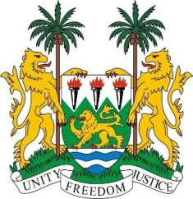
SIERRA LEONE
29th Session of the UPR

LUXEMBOURG

18 January 2018

Mr President,

Sierra Leone welcomes the Luxembourg delegation to this session and thanks them for today’s presentation. We commend Luxembourg for its financial contribution made to the OHCHR since 2013.

My delegation applauds the measures taken to further promote and protect human rights - including the ratification (in 2017) of the Convention on the Reduction of Statelessness of 1961, as well as the OP-ICESCR (2015) and (in 2016), the OP-CRC on the communications procedure.

Sierra Leone also notes that the National Action Plan for Equality between Women and Men (2015-2018) is being incorporated into national systems and that several policies and measures have been implemented to combat human trafficking and to protect children from sexual exploitation.

Sierra Leone notes however with concern that the National Council for Foreigners has not renewed the mandate of the special standing commission to combat racial discrimination and would like to encourage Luxembourg to consider reallocating powers to this commission in order to maintain the scope of the issue of racial discrimination.
My delegation also encourages Luxembourg to expedite the legislative reforms necessary to ensure the acquisition of nationality is accorded to children born out of wedlock.

Recommendations:

- Accede to the ICPPED.
- Ratify the Istanbul Convention.
- Ensure that minors are not detained in holding centres or prisons, nor kept in solitary confinement.
- Modify the Criminal Code and other legislation to ensure that all children are fully protected from child prostitution.

Sierra Leone wishes the Luxembourg every success in completing their third review cycle.

Thank you, Mr President.

