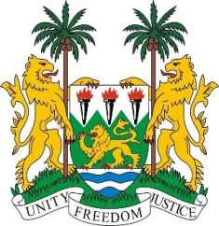
SIERRA LEONE
29th Session of the UPR

BURUNDI

18 January 2018

Mr President,

Sierra Leone welcomes the delegation from Burundi to this session and thanks them for their presentation.

My delegation notes, with satisfaction, the various Acts on the promotion and protection of human rights have been promulgated since the last UPR.
Sierra Leone applauds the measures taken to raise awareness as regards persons with albinism and for allocating resources to meet their health and educational needs.

My delegation is however concerned by the reports of insecurity and violence which has led to mass internal displacement and an estimated 320,000 refugees.

It is encouraging that Burundi has established a Truth and Reconciliation Commission (TRC) and a National Commission for Dialogue (CNDI). Based on its own experience, Sierra Leone would encourage that a parallel mechanism is put in place to ensure that persons accused of crimes against humanity are brought to justice.

Recommendations:

- Ratify the ICRMW and accede to the ICPPED.
- Expedite the ratification of the Status of Stateless Persons and the (1961) Convention on the Reduction of Statelessness.
- Ensure that allegations on violence against women are thoroughly investigated and perpetrators brought to justice.
- Remove all discriminatory provisions between men and women relating to their ability to pass their nationality to their children.

Sierra Leone wishes the Burundi every success in completing their third review cycle.

Thank you, Mr President.

