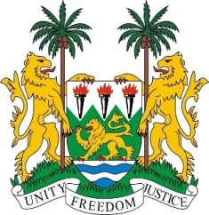
SIERRA LEONE

29th Session of the UPR

BAHAMAS

17 January 2018

Mr President,

Sierra Leone welcomes the Bahamian delegation to this review session and thanks them for their comprehensive presentation.

My delegation commends the Bahamas on the ongoing efforts to implement its Vision 2040 National Development Plan of The Bahamas (2015–2040), and on ratifying the Convention on the Rights of Persons with Disabilities, as well as on the adoption of the Persons with Disabilities (Equal Opportunities) Act of 2014. We also wish to congratulate the Bahamas on its level of human development.

We further applaud the efforts taken by the government to harmonize its legislation to match its international human rights obligations and commitments. Notable in this respect are: the Child Protection (Amendment) Act of 2014 and in 2015, the Optional Protocol on the Sale of Children, Child Prostitution and Child Pornography.

Sierra Leone would however encourage the Bahamas to consider establishing bilateral and multilateral agreements in order to effectively address trafficking in persons regionally.

Recommendations:

- Ratify the ICRMW and the ICPPED and accede to the CAT.
- Ratify the1961 Convention on the Reduction of Statelessness.
- Modify national laws to ensure equal nationality rights and that nationality can be passed on to Bahamian children regardless of whether or not their parent was born in the Bahamas post-1973.
- Seek the technical and financial support needed to meet its climate change needs.

Sierra Leone wishes the Bahamas every success in completing their third review cycle.

Thank you, Mr President.

