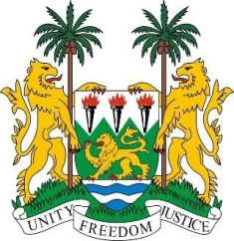
SIERRA LEONE
29th Session of the UPR

BOTSWANA

17 January 2018

Mr Vice-President,

Sierra Leone warmly welcomes the distinguished delegation from Botswana to this review session and thanks them for today’s presentation.

My delegation commends Botswana for the various measures implemented since their last UPR cycle in 2013, notably the National Development Plan II and Botswana’s Vision 2036, and poverty reduction strategies that have yielded positive results, and its comprehensive approach to address HIV/AIDS.

Sierra Leone applauds Botswana for submitting a Voluntary Interim (UPR) Report in 2015, and for also incorporating various socio-political and development measures including the Women’s Economic Empowerment Programme and the adoption of the Education and Training Sector Strategic Plan.

Sierra Leone would however encourage Botswana to continue to develop enforceable measures aimed at eliminating child, early and forced marriage in rural areas, and to provide universal birth registration for all children born on its territory.

Recommendations:

- Ratify the core international legal instruments; including the ICESCR, CRPD, ICRMW and the ICPPED.
- Expedite the establishment of a national human rights institution in conformity with the Paris Principles
- Ratify the 1961 Convention on the Reduction of Statelessness.
- Amend its legislation in order to grant nationality to any child born in Botswana who would otherwise be stateless as well as to foundlings.

Sierra Leone wishes Botswana every success in completing their third review cycle.

Thank you, Mr Vice-President.

