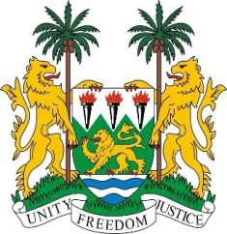
SIERRA LEONE
29th Session of the UPR

MALI

16 January 2018

Mr President,

Sierra Leone warmly welcomes the delegation from Mali to this review session and thanks them for their oral update.

Sierra Leone applauds the determination and commitment shown by the Government of Mali to establish a viable transitional justice mechanism - in spite of the many challenges faced since 2012.

My delegation commends Mali on the progress made in promoting human rights, notably, the creation of a Ministry of Human Rights and State Reform in 2017 and the establishment of the National Human Rights Commission in 2016.

Sierra Leone notes the government’s request for technical assistance, for human rights institutions and civil society organizations to address challenges in the implementation of the Agreement for Peace and Reconciliation resulting from the Algiers Process, and to enable the continuation of current efforts to promote and protect human rights, prepare reports and implement the recommendations of the treaty bodies and the UPR.

Sierra Leone encourages the government to expedite the finalisation of the strategic plan 2016-2018 on the implementation of the national programme for gender equality.

Recommendations:

- Establish the same age of marriage for boys and girls as 18, and strengthen efforts aimed at ending child, early and forced marriage.
- Implement measures which promote gender equality and ensure better access of women to decision-making positions.
- Expedite efforts to adopt legislation to combat gender-based violence and establish a national programme to combat sexual exploitation of women and children.

Sierra Leone wishes Mali every success in completing their third review cycle.

Thank you, Mr President.

