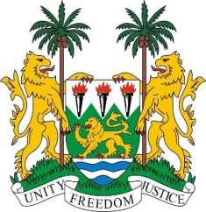
SIERRA LEONE
29th Session of the UPR

ROMANIA

16 January 2018

Mr Vice-President,

Sierra Leone welcomes the delegation of Romania to this review session and thanks them for their oral update.

My delegation notes that since their last UPR, Romania has notably established the National Strategy on the Protection and Promotion of Children’s Rights 2014-2020 and the National Strategy on Children’s and Adolescents’ Mental Health 2016-2020. In 2014, their new Civil and Criminal Codes came into force. The new Criminal Procedure Code effectively criminalises the trafficking in persons.

Sierra Leone notes that the National Report recognises that improvements are needed in ensuring further protection and promotion of the rights of the children (especially Roma children and children with disabilities) as regards their right to education and the right to health, and the need for institutional consolidation and official recognition of Romanian institutions active in the field of human rights. My delegation encourages Romania to intensify its efforts on these matters.

Recommendations:

- Accede to the ICPPED and to the Optional Protocols which they have committed to, notably the OP-CRPD and OP-ICESCR.
- Strengthen legislative efforts to end child, early and forced marriage and the sexual exploitation of children.
- Establish adequate legislative measures which guarantee women’s property rights after divorce, particularly in the case of unregistered marriages.
- Implement measures aimed at strengthening the social inclusion of the Roma people, including the participation of Roma children in the school system.

Sierra Leone wishes Romania every success in completing their third review cycle.

Thank you, Mr Vice-President.

