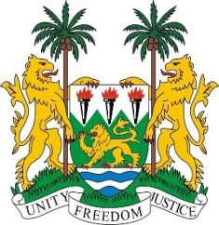
SIERRA LEONE
29th Session of the UPR

TONGA

15 January 2018

Mr Madame Vice-President,

Sierra Leone welcomes the distinguished delegation from Tonga to this third review cycle and thanks them for today’s presentation.

My delegation commends Tonga on the efforts made to adapt its national legislation in order to meet its human rights commitments. It is notable that since their last review, the government has established various measures including the New Education Act of 2013 and the Parliament recently approved the National Policy on Disability Inclusive Development 2014-2018.

It is also commendable that Tonga became a member of the ILO in 2016 and since 2013, was extended a standing invitation to all special procedure mandate holders.

Sierra Leone also notes that Tonga established the Family Protection Act of 2013 to better protect women from domestic violence and girls from corporal punishment.

However, Sierra Leone would encourage Tonga to expedite efforts to ratify the Convention on the Rights of Persons with Disabilities (CRPD) and to continue to engage national participation in order to ratify the Convention on the Elimination of All Forms of Discrimination against Women (CEDAW) in the near future.

Recommendations:

- Sign and accede to the core international human rights treaties to which Tonga is not yet party to, namely, the ICESCR, ICCPR, ICPPED, ICRMW and the CAT.
- Establish a National Human Rights Institution in conformity with the Paris Principles.
- Establish national policies which ensure better participation of women in all levels of government and in key decision-making positions.
- Modify national legislation to prohibit child, early and forced marriage and establish a clearly defined legal age of marriage and consent.
- Seek the technical and financial assistance needed to adequately address the climate change challenges and to reduce risk and implement early warning systems.

Sierra Leone wishes Tonga every success in completing its UPR cycle.

Thank you, Madam Vice-President.

