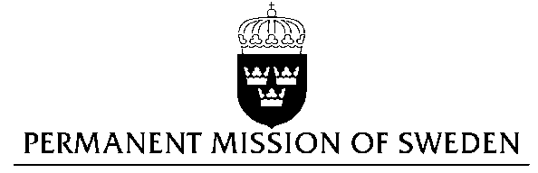
UN Human Rights Council

UPR 29th session

Statement by Sweden in the interactive dialogue on the United Arab Emirates

Delivered by Minister-Counsellor Karin Bolin
Geneva, 22 January 2018 (speaking time 1.10)

Mr. President,

Sweden wishes to welcome the delegation of the United Arab Emirates and extends its thanks for the report and the presentation.

Sweden recommends the Government of the United Arab Emirates to:

- Issue a standing invitation to Human Rights Council’s special procedures and mechanisms, and to accept a visit by the Special Rapporteur on the Situation of Human Rights Defenders.

- Amend the Cybercrime law (2012), the Antiterror law (2014) and provisions of the penal code restricting freedom of expression in order to bring them into conformity with international standards.

- Ensure full implementation of recently updated labour legislation in order to secure that employers and sponsors fully respect the economic, social and cultural rights of migrants and domestic workers.

- Reform discriminatory evidence standards for prosecution of rape and to train police and judicial personnel on handling cases of sexual and gender based violence.

- Enact legislative reforms to ensure non-discrimination of women, including in relation to marriage, divorce and inheritance.

Sweden wishes the Government of the United Arab Emirates all success in the current review and in implementing the recommendations.

I thank you Mr. President

