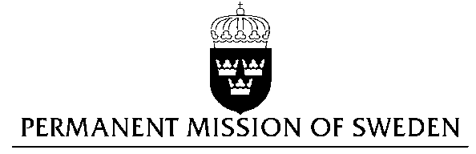
UN Human Rights Council

UPR 29th session

Statement by Sweden in the interactive dialogue on Serbia

Delivered by H.E Ms Veronika Bard
Geneva, 24 January 2018 (speaking time 1.30)

Mr. President,

Sweden wishes to welcome the delegation of Serbia and extends its thanks for the report and the presentation. Sweden acknowledges the continued work of the Government of Serbia to fulfil its obligations with regard to human rights and encourages further efforts.

Sweden recommends the Government of Serbia:

- to conclude the work on a new media strategy, in full partnership with civil society, and to ensure that the strategy is in conformity with Serbia’s international obligation and is fully implemented once adopted,

- to ensure that the discussions on constitutional reforms regarding the independence of the judiciary move ahead in a timely and inclusive manner and that the outcome of this process is swiftly implemented,

- to fully cooperate with MICT and implement the War Crimes Prosecution Strategy.

Sweden wishes the Government of Serbia all success in the current review and in implementing the recommendations.

I thank you Mr. President

