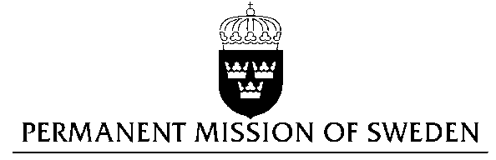
UN Human Rights Council

UPR 29th session

Statement by Sweden in the interactive dialogue on Romania

Delivered by Counsellor Anna Envall
Geneva, 16 January 2018

Mr. President,

Sweden wishes to welcome the delegation of Romania and extends its thanks for the report and the presentation. Sweden acknowledges the continued work of the Government of Romania to fulfil its obligations with regard to human rights and encourages further efforts.

Sweden recommends the Government of Romania to:

- Comply with all the EU Commission’s CVM recommendations and make sure those reforms are irreversible and sustainable in order to allow for the CVM mechanism to be concluded

- develop an effective follow up system of the implementation of the National Strategy for the inclusion of Roma in the society with clear measurable targets and assigned responsibility to follow up progress

- consider introducing obligatory information in schools about the historic treatment of Roma and to develop programs to counter negative stigma in schools as well as in different public institutions.
- introduce civil legal partnership between same-sex couples.

Sweden wishes the Government of Romania all success in the current review and in implementing the recommendations.
I thank you Mr. President

