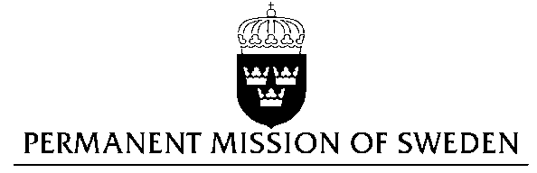
UN Human Rights Council

UPR 29th session

Statement by Sweden in the interactive dialogue on Mali
Delivered by Minister-Councellor Karin Bolin
Geneva, 16 January 2018 (speaking time 1.30)

Mr. President,

Sweden wishes to welcome the delegation of Mali and extends its thanks for the report and the presentation. Sweden acknowledges the continued work of the Government of Mali to fulfil its obligations with regard to human rights and encourages further efforts. Sweden welcomes important steps taken not least with regard to increasing the participation of women in decision-making. In the last review, the Government of Mali accepted recommendations to hold perpetrators of human rights violations and abuses accountable. However, impunity persists which has also been highlighted by the UN Independent Expert on Mali.

In view of this, Sweden recommends the Government of Mali to:

- Take all necessary measures to ensure impartial and effective investigations by civilian authorities into all allegations of crimes under international law, including international human rights law, in order to identify and prosecute those responsible, while ensuring fair trials.

- Establish an international commission of inquiry as provided for in the Algiers Peace Agreement.
- Ensure the full and meaningful participation of women in all political processes in Mali, particularly processes regarding the Algiers peace agreement.
Sweden wishes the Government of Mali all success in the current review and in implementing the recommendations.

I thank you Mr. President

