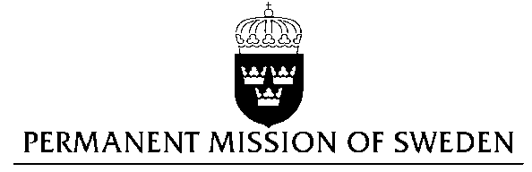
UN Human Rights Council

UPR 29th session

Statement by Sweden in the interactive dialogue on Israel
Delivered by Minister-Councellor Karin Bolin
Geneva, 23 January 2018 (speaking time 1.25)

Mr. President,

Sweden wishes to welcome the delegation of Israel and extends its thanks for the report and presentation. Sweden acknowledges the continued work of the Government of Israel to fulfil its obligations with regard to human rights and encourages further efforts.

Sweden recommends the Government of Israel to:

- Ensure that no forcible transfer of population is conducted in Area C and to take proactive measures to increase access to clean water, electricity, education and health services for Palestinians in Area C.

- Ensure that civil society organisations are able to carry out their work in a secure and free environment, without undue restrictions and intimidations.

- Ensure that the use of administrative detention is limited to temporary and exceptional cases, and that international law, including human rights law, is fully respected, in particular regarding children held in administrative detention.

Sweden wishes the Government of Israel all success in the current review and in implementing the recommendations.

I thank you Mr. President

