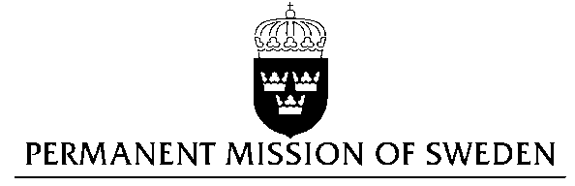
UN Human Rights Council

UPR 29th session

Statement by Sweden in the interactive dialogue on France

Delivered by H.E Ms Veronika Bard
Geneva, 15 January 2018 (speaking time 1.05)

Mr. President,

Sweden wishes to welcome the delegation of France and extends our thanks for the report and the presentation. Sweden acknowledges the continued work of the Government of France to fulfil its obligations with regard to human rights and encourages further efforts.

Sweden recommends the Government of France to:

- Adopt legislation explicitly prohibiting all forms of corporal punishment of children in all settings and to sanction perpetrators of such violence against children,
- Establish a minimum age of criminal responsibility, not below the age of 15, and to end the treatment of children over 16 years of age as adults, including when involved in violent extremist activities,
- Reduce overcrowding in French prisons and improve the conditions for the detainees, including allocating greater resources to rehabilitation.

Sweden wishes the Government of France all success in the current review and in implementing the recommendations.

I thank you Mr. President

