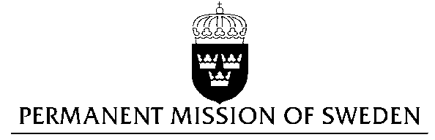
UN Human Rights Council

UPR 29th session

Statement by Sweden in the interactive dialogue on Burundi

Delivered by Minister-Councellor Karin Bolin
Geneva, 18 January 2018 (speaking time 1:15)

Mr. President,

Sweden wishes to welcome the delegation of Burundi and extends its thanks for the report and the presentation.

Sweden recommends the Government of Burundi to:

- Ensure due investigation into the findings of the CoI with regard to gross human rights violations and international crimes, and to ensure that alleged perpetrators are promptly prosecuted in credible, independent and fair judicial procedures.

- Fully cooperate with ICC’s investigation regarding crimes within the ICC’s jurisdiction and allegedly committed in Burundi, or by Burundian nationals outside Burundi, between April 26, 2015 and October 26, 2017.
- Review laws adopted in 2017 regarding non-profit organisations and foreign NGOs, and to lift suspensions and reverse revocation of licences for media and civil society organisations so they can resume their activities with complete independence.

Sweden wishes the Government of Burundi all success in the current review and in implementing the recommendations.

I thank you Mr. President

