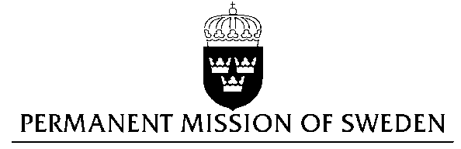
UN Human Rights Council

UPR 29th session

Statement by Sweden in the interactive dialogue on Botswana

Delivered by H.E Ms Veronika Bard
Geneva, 17 January 2018 (speaking time 1.25)

Mr. President,

Sweden wishes to welcome the delegation of Botswana and extends its thanks for the report and the presentation. Sweden acknowledges the continued work of the Government of Botswana to fulfil its obligations with regard to human rights and encourages further efforts.

Sweden recommends the Government of Botswana to:

- Decriminalize consensual, same-sex sexual acts.
- Accede to the second Optional Protocol of the ICCPR, aiming at the abolition of the death penalty, and to adopt a formal moratorium and commute all death sentences to prison terms.

Sweden wishes the Government of Botswana all success in the current review and in implementing the recommendations.

I thank you Mr. President

