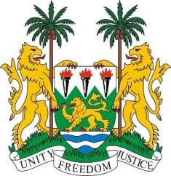
SIERRA LEONE
29th Session of the UPR

FRANCE

15 January 2018

Mr President,

Sierra Leone welcomes the French delegation and thanks them for their presentation.

My delegation commends France for establishing a National Action Plan to Combat Racism and Anti-Semitism (2015-2017), and a working group to fight racism on the internet. Also notable are; “Strategy Europe 2020”, the ratification of Arms Trade Treaty in 2014, and two optional protocols (in 2016 and 2017)

My delegation would like to encourage France to consider withdrawing its declarations on Article 4 of the CERD and Article 27 of the CCPR, in the light of resurgence of racist and xenophobic discourse against persons of ethnic, religious and linguistic minorities and to launch the Decade of the International Decade of People of African Descent.

Recommendations:

- Establish a minimum age of criminal responsibility to be above 13.
- Reinforce the existing anti-discrimination measures and policies to combat all forms of discrimination against women and girls from racial and religious minorities.
- Establish cohesive long-term strategies to provide access to safe drinking water and sanitation for migrants in Calais and in the north of France.
- Increase ODA to the 0.7 percent of GDP target.

Sierra Leone wishes France every success in completing its third review cycle.

Thank you, Mr President.

