Check against delivery

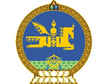

29th Session of the UPR Working Group
Mongolia’s statement at the Review of Luxembourg
18 January 2018

Mr. President,

Mongolia welcomes the delegation of Luxembourg and thanks for the presentation of their national report.

My delegation commend Luxembourg for building the institutional framework of human rights by ratifying a number of important instruments, including the Optional Protocol to the Convention on the Rights of the Child on a communications procedure, and recommend Luxembourg to ratify the International Convention for the Protection of All Persons from Enforced Disappearance.

While taking positive note on the improvements in combatting discrimination against women we recommend the Government to continue making progress in empowering women and enhance their role in political and economic life.

I thank you Mr. President.

