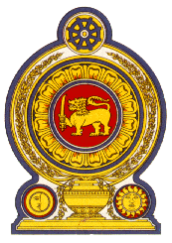

Statement by the Democratic Socialist Republic of Sri Lanka
29th Session of the Universal Periodic Review
Review of the United Arab Emirates – 22 January 2018

Mr. President,

Sri Lanka welcomes the delegation of the United Arab Emirates and notes with appreciation its national report and the oral update.
Sri Lanka welcomes the establishment in March 2013, of a Human Rights Committee, as a standing committee of the Federal National Council and progressive efforts of the Government to promote gender equality and women empowerment, in particular the establishment of the United Arab Emirates Gender Balance Council in 2015 and the National Strategy for the Empowerment and Advancement of Emirati Women (2015–2021).
Sri Lanka takes note of the launching of the Innovation in Labour Market Governance Programme in May 2016 and also welcomes the efforts of the UAE to combat human trafficking, including through its partnership with the private sector.
As the Chair of the Abu Dhabi Dialogue (ADD), Sri Lanka appreciates the proactive initiatives both at national and regional levels taken by the UAE Labour Ministry to improve the conditions of Asian contractual labour migrants in the UAE.
Sri Lanka wishes to recommend that the UAE :
- Takes further steps to improve participation and engagement of women in political work and legislative processes of the country;
- Continues to improve measures to protect the rights of the foreign migrant workers; and further improves measures aimed at combating human trafficking including victim assistance.

We wish the UAE success in its UPR engagement.
Thank you.

