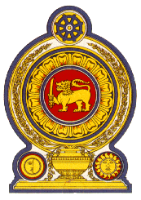

Statement by the Democratic Socialist Republic of Sri Lanka
29th Session of the Universal Periodic Review
Review of the Republic of Burundi– 18 January 2018

Mr. President,

Sri Lanka extends a warm welcome to the High Level delegation from the Republic of Burundi and appreciates the informative presentation made by the delegation.

We take positive note of the follow-up action taken on recommendations accepted by the Republic of Burundi, during the 2nd cycle of the UPR. We welcome the efforts made by the Government of the Republic of Burundi to ratify the Optional Protocol to the Convention against Torture in September 2013, and the Convention on the Rights of Persons with Disabilities in March 2014.

We note the continued efforts of the Government to implement the National Gender Policy Action Plan 2012-2016. Sri Lanka recommends that Burundi
- continues to take concrete measures to reduce the high ratio of maternal and infant mortality by improving access to basic prenatal and postnatal care, emergency obstetric services and skilled birth attendance;

- Continue efforts being taken to improve access to health through the national health policy 2016-2025 and to improve universal access to basic education.

We wish the Republic of Burundi success in its UPR engagement.
Thank you.

